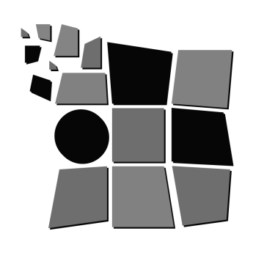
The Timmins Museum:
National Exhibition Centre

Your visual arts & heritage destination in Timmins!

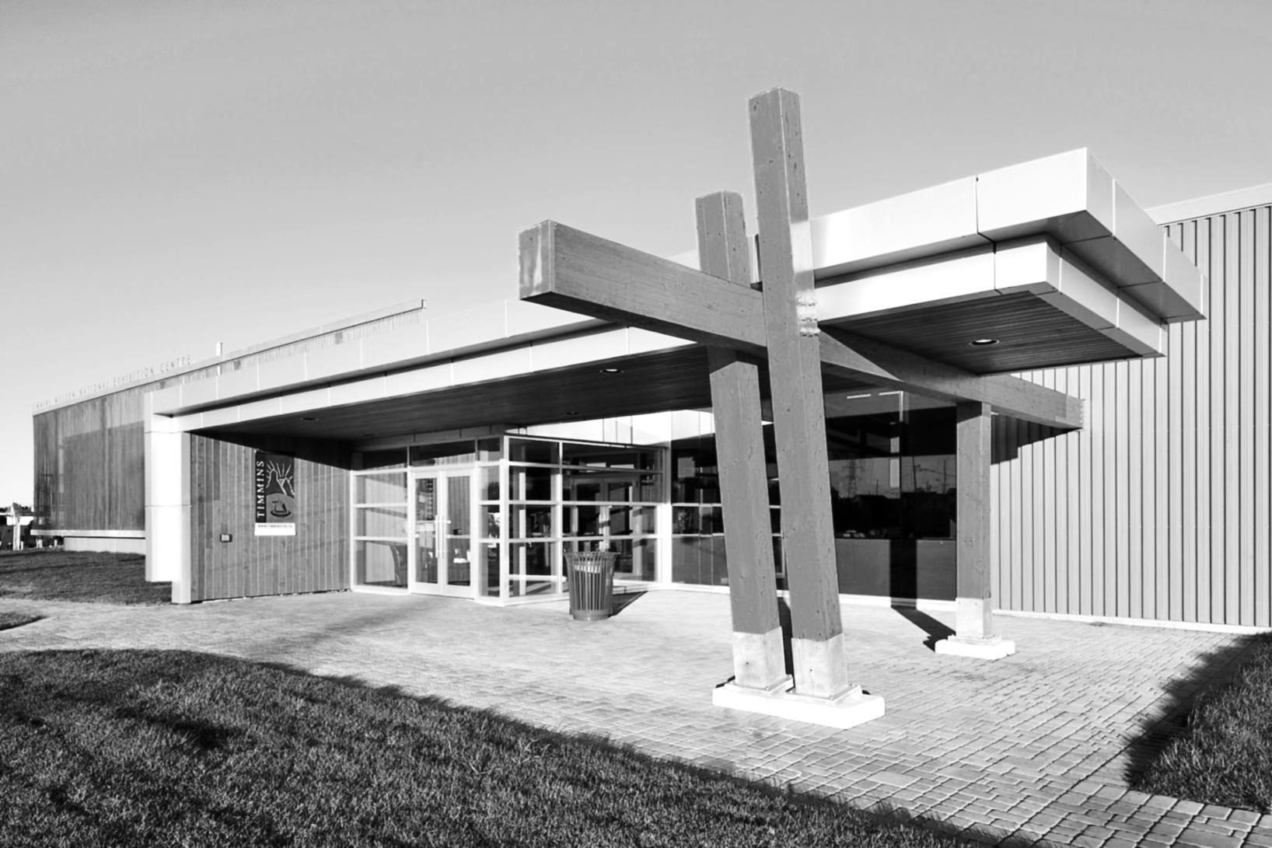
Open Year Round
Seven Days a Week

- Local & Travelling Exhibitions
- Research Library
- Photo Archives
- Local History
- Gift Shop
- Programming & Workshops

325 Second Ave.
Timmins, ON
P4N 0B3
705-360-2617

http://www.timminsmuseum.ca
museum@timmins.ca

